**1)      Download appropriate file for your system from** <http://developer.android.com/sdk/index.html>

**2)     Run “ installer_r16-windows.exe”**

**3) Choose the packages that you wish install (I installed Android 2.1)**

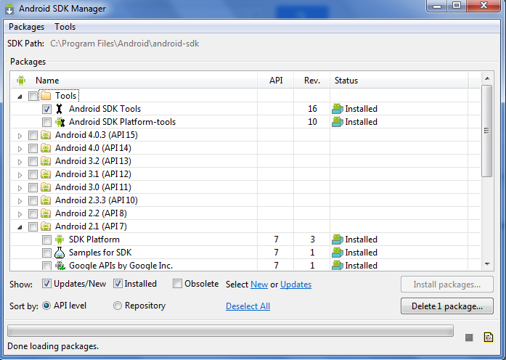

**4) Create a new Android Virtual Device (AVD)**

a. Select Tools -> Manage AVDs.. from Android SDK Manager

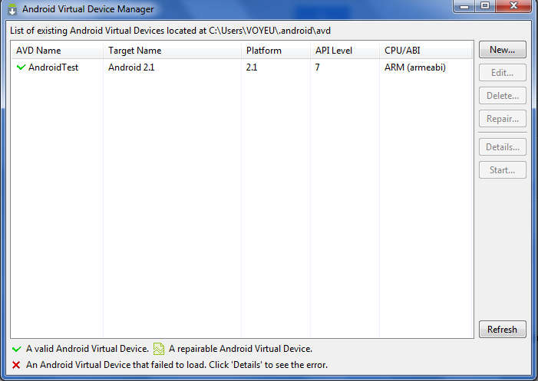

Click “New”

Enter a Name

Choose a Target

   Enter a size for the emulated SD Card

   Choose a Skin ( Leave the default value)

Click Create AVD

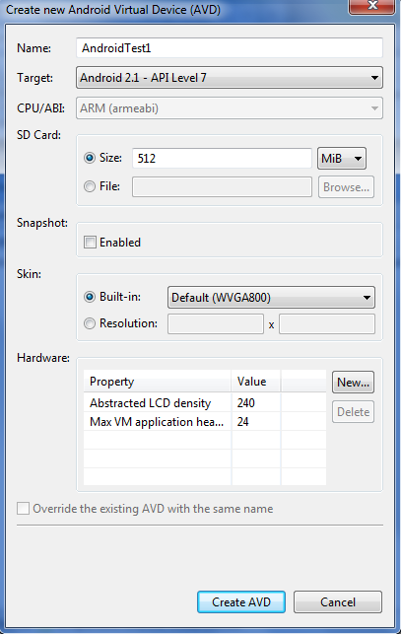

**5) Start your newly created Virtual Device**

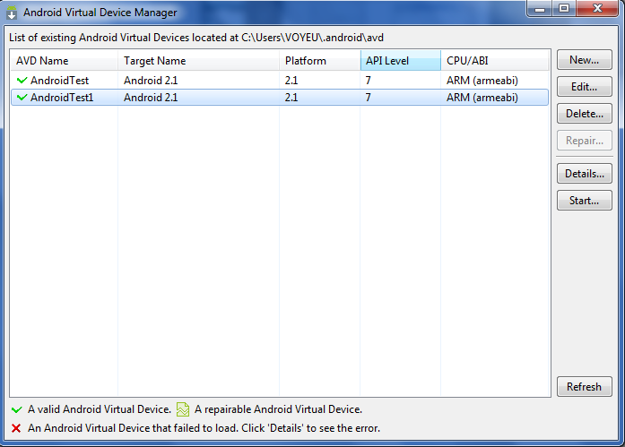

a.       Choose the Virtual Device from the list

b.      Click “Start…”

c.       Click “Launch”

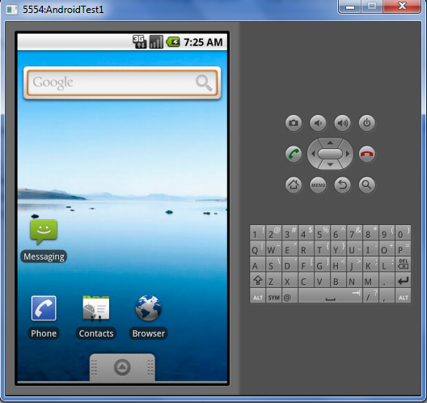

Let’s start by making a call and send sms

Start two emulators and call each other

5554 calling 5556

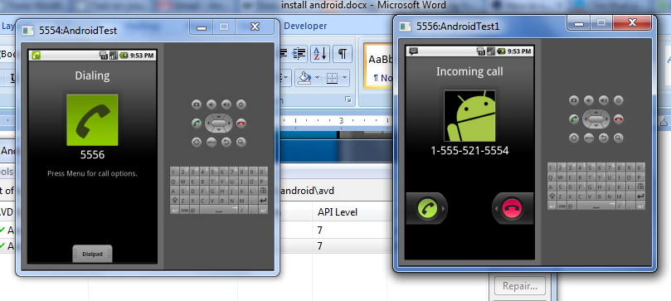

Press F3 to accept the call

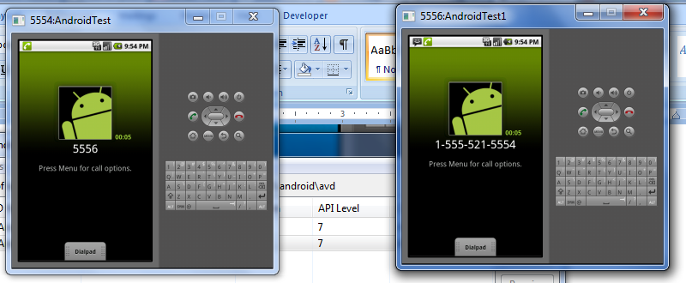

Press F4 to end the call

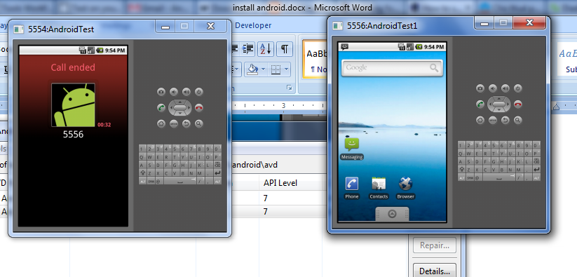

Another way

1. First start your emulator and make sure it’s running.  
2. Then go to command prompt in windows

3. Type **telne**t and press enter

(By default telnet is not enabled in Windows Vista and Windows 7.So you need to turn own the option for telnet

* **Open control Panel**
* **Programs and features**
* **Turn Windows feature On or OFF**
* **Check Telnet Client.)**

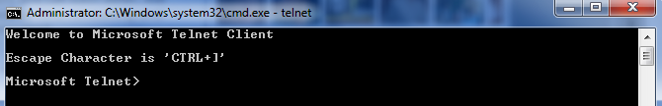

4. Type o localhost 5554 and press enter.(if your emulator serial number is 5554)

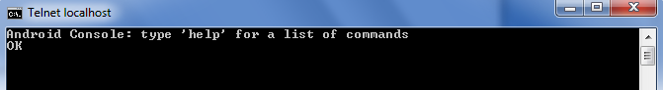

5. To call use gsm call phone_number

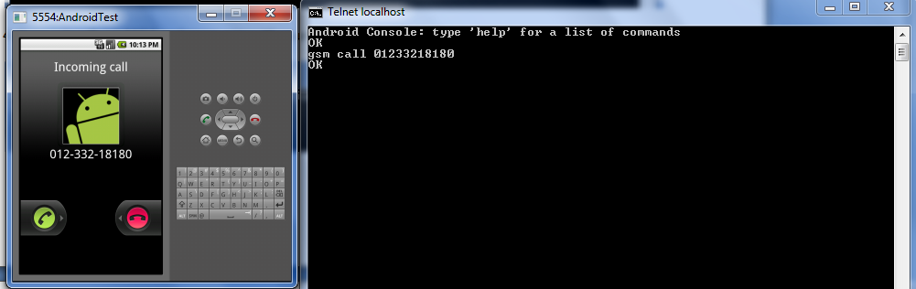

**6. to accept use gsm accept phone_number ( or Press F3 )**

**7. to cancel use gsm cancel phone_number ( or Press F4 )**

Send sms

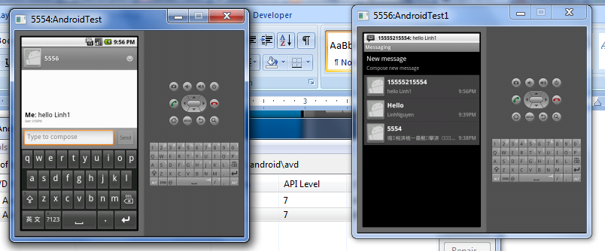

Below are emulator keyboard mapping

